**Java Networking**

* Java Networking is a concept of connecting two or more computing devices together so that we can share resources.
* Java socket programming provides facility to share data between different computing devices.

**Advantage of Java Networking**

1. sharing resources
2. centralize software management

**Java Networking Terminology**

The widely used java networking terminologies are given below:

1. IP Address
2. Protocol
3. Port Number
4. MAC Address
5. Connection-oriented and connection-less protocol
6. Socket

1) IP Address

* IP address is a unique number assigned to a node/computer of a network e.g. 192.168.0.1. It is composed of octets that range from 0 to 255.
* It is a logical address that can be changed.

2) Protocol

A protocol is a set of rules basically that is followed for communication.

For example:

* TCP
* FTP
* Telnet
* SMTP
* POP etc.

3) Port Number

* The port number is used to uniquely identify different applications. It acts as a communication endpoint between applications.
* The port number is associated with the IP address for communication between two applications.

4) MAC Address

MAC (Media Access Control) Address is a unique identifier of NIC (Network Interface Controller). A network node can have multiple NIC but each with unique MAC.

5) Connection-oriented and connection-less protocol

In connection-oriented protocol, acknowledgement is sent by the receiver. So it is reliable but slow. The example of connection-oriented protocol is TCP.

But, in connection-less protocol, acknowledgement is not sent by the receiver. So it is not reliable but fast. The example of connection-less protocol is UDP.

6) Socket

A socket is an endpoint between two way communications.

(**An endpoint is a remote computing device that communicates back and forth with a network to which it is connected**. **meaning** they pass information **back and forth**)

**Java Socket Programming**

* Java Socket programming is used for communication between the applications running on different JRE.
* Java Socket programming can be connection-oriented or connection-less.
* **Socket** and **ServerSocket** classes are used for connection-oriented socket programming
* **DatagramSocket** and **DatagramPacket** classes are used for connection-less socket programming.

The client in socket programming must know two information:

* IP Address of Server, and
* Port number.

**Socket class**

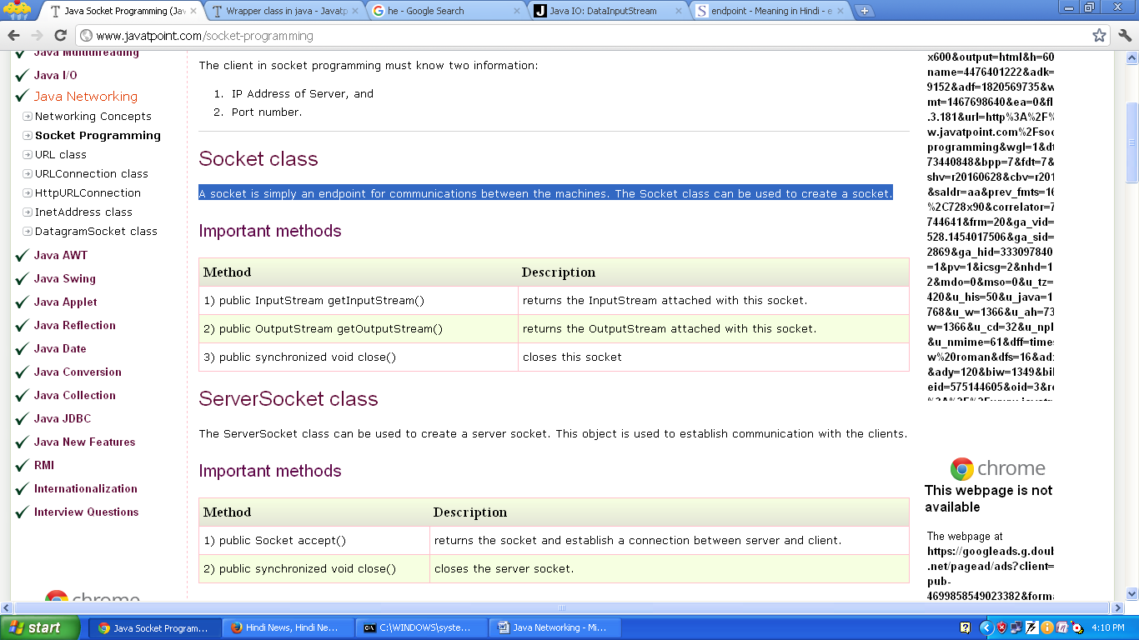A socket is simply an endpoint for communications between the machines. The Socket class can be used to create a socket.

**ServerSocket**

* The **ServerSocket** class can be used to create a server socket.
* **ServerSocket** object is used to establish communication with the clients.

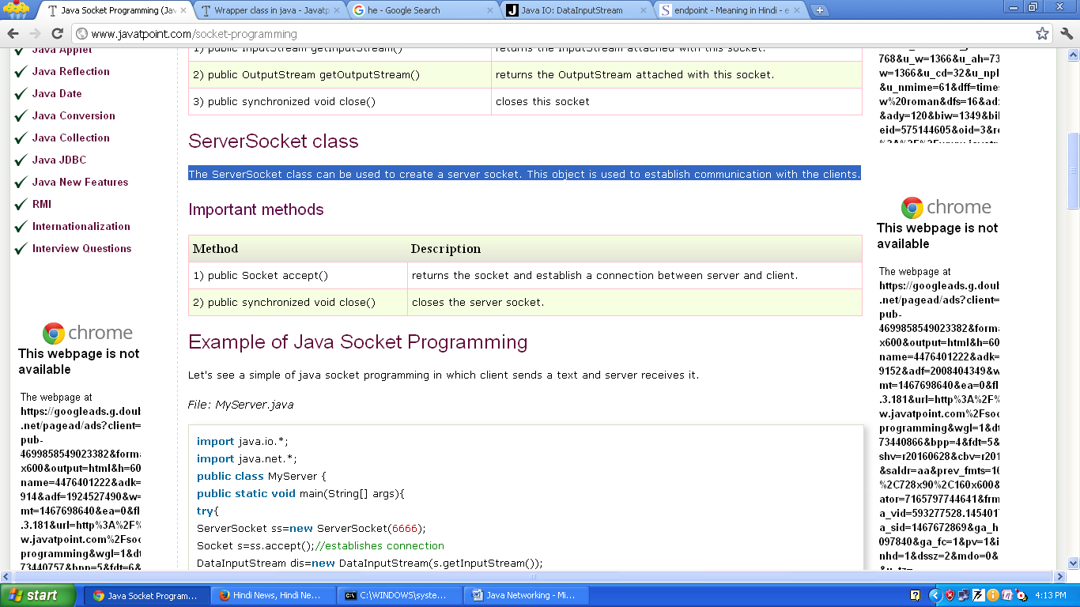

**Example:** socket programming in which client sends a text and server receives it.

File: MyServer.java

**import java.io.*;**

**import java.net.*;**

**public class MyServer {**

**public static void main(String[] args){**

**try{**

**ServerSocket ss=new ServerSocket(6666);**

**Socket s=ss.accept(); //establishes connection**

**DataInputStream dis=new DataInputStream(s.getInputStream());**

**String str=(String)dis.readUTF();**

**System.out.println("message= "+str);**

**ss.close();**

**}catch(Exception e){System.out.println(e);}**

**}**

**}**

File: MyClient.java

**import java.io.*;**

**import java.net.*;**

**public class MyClient {**

**public static void main(String[] args) {**

**try{**

**Socket s=new Socket("localhost",6666);**

**DataOutputStream dout=new DataOutputStream(s.getOutputStream());**

**dout.writeUTF("Hello Server");**

**dout.close();**

**s.close();**

**}catch(Exception e){System.out.println(e);}**

**}**

**}**

**Process: To execute this program open two command prompts and execute each program at each command prompt.**

**After running the client application, a message will be displayed on the server console.**

**Example of Java Socket Programming (Read-Write both side)**

In this example, client will write first to the server then server will receive and print the text. Then server will write to the client and client will receive and print the text. The step goes on.

File: MyServer.java

**import java.net.*;**

**import java.io.*;**

**class MyServer{**

**public static void main(String args[])throws Exception{**

**ServerSocket ss=new ServerSocket(3333);**

**Socket s=ss.accept();**

**DataInputStream din=new DataInputStream(s.getInputStream());**

**DataOutputStream dout=new DataOutputStream(s.getOutputStream());**

**BufferedReader br=new BufferedReader(new InputStreamReader(System.in));**

**String str="",str2="";**

**while(!str.equals("stop")){**

**str=din.readUTF();**

**System.out.println("client says: "+str);**

**str2=br.readLine();**

**dout.writeUTF(str2);**

**dout.flush();**

**}**

**din.close();**

**s.close();**

**ss.close();**

**}}**

File: MyClient.java

**import java.net.*;**

**import java.io.*;**

**class MyClient{**

**public static void main(String args[])throws Exception{**

**Socket s=new Socket("localhost",3333);**

**DataInputStream din=new DataInputStream(s.getInputStream());**

**DataOutputStream dout=new DataOutputStream(s.getOutputStream());**

**BufferedReader br=new BufferedReader(new InputStreamReader(System.in));**

**String str="",str2="";**

**while(!str.equals("stop")){**

**str=br.readLine();**

**dout.writeUTF(str);**

**dout.flush();**

**str2=din.readUTF();**

**System.out.println("Server says: "+str2);**

**}**

**dout.close();**

**s.close();**

**}}**

**Java DatagramSocket and DatagramPacket**

Java **DatagramSocket** and **DatagramPacket** classes are used for connection-less socket programming.

**DatagramSocket class**

* Java **DatagramSocket** class represents a **connection-less socket for sending and receiving datagram packets.**
* **A datagram is basically information** but there is no guarantee of its content, arrival or arrival time.

**Commonly used Constructors of DatagramSocket class**

* **DatagramSocket()** throws SocketException:

It creates a datagram socket and binds it with the available Port Number on the localhost machine.

* **DatagramSocket(int port)** throws SocketException:

It creates a datagram socket and binds it with the given Port Number.

* **DatagramSocket(int port, InetAddress address)** throws SocketException:

It creates a datagram socket and binds it with the specified port number and host address.

**DatagramPacket class**

Java **DatagramPacket** is a message that can be sent or received. If you send multiple packets, it may arrive in any order. Additionally, packet delivery is not guaranteed.

**Commonly used Constructors of DatagramPacket class**

* **DatagramPacket(byte[] barr, int length):** it creates a datagram packet.

This constructor is used to receive the packets of length length. The length must be less than or equal to the barr.length.

* **DatagramPacket(byte[] barr, int length, InetAddress address, int port):** it creates a datagram packet.

This constructor is used to send the packets of the length to the specified port on the specified host.

The length must be less than or equal to the barr.length.

**barr** – the Packet data

**length**- the packet length

**address**- destination address

**port**- destination port number

Example: //DSender.java

**import java.net.*;**

**public class DSender{**

**public static void main(String[] args) throws Exception {**

**DatagramSocket ds = new DatagramSocket();**

**String str = "Welcome java";**

**InetAddress ip = InetAddress.getByName("127.0.0.1");**

**DatagramPacket dp = new DatagramPacket(str.getBytes(), str.length(), ip, 3000);**

**ds.send(dp);**

**ds.close(); encoding this string into a sequence of bytes**

**}**

**}**

**//DReceiver.java**

**import java.net.*;**

**public class DReceiver{**

**public static void main(String[] args) throws Exception {**

**DatagramSocket ds = new DatagramSocket(3000);**

**byte[] buf = new byte[1024];**

**DatagramPacket dp = new DatagramPacket(buf, 1024);**

**ds.receive(dp);**

**String str = new String(dp.getData(), 0, dp.getLength());**

**System.out.println(str);**

public String(byte[] bytes, int offset, int length)

bytes – the bytes to decoded into characters

offset – the index of the first byte to decode

length – The number of bytes to decode.

**ds.close();**

**}**

**}**